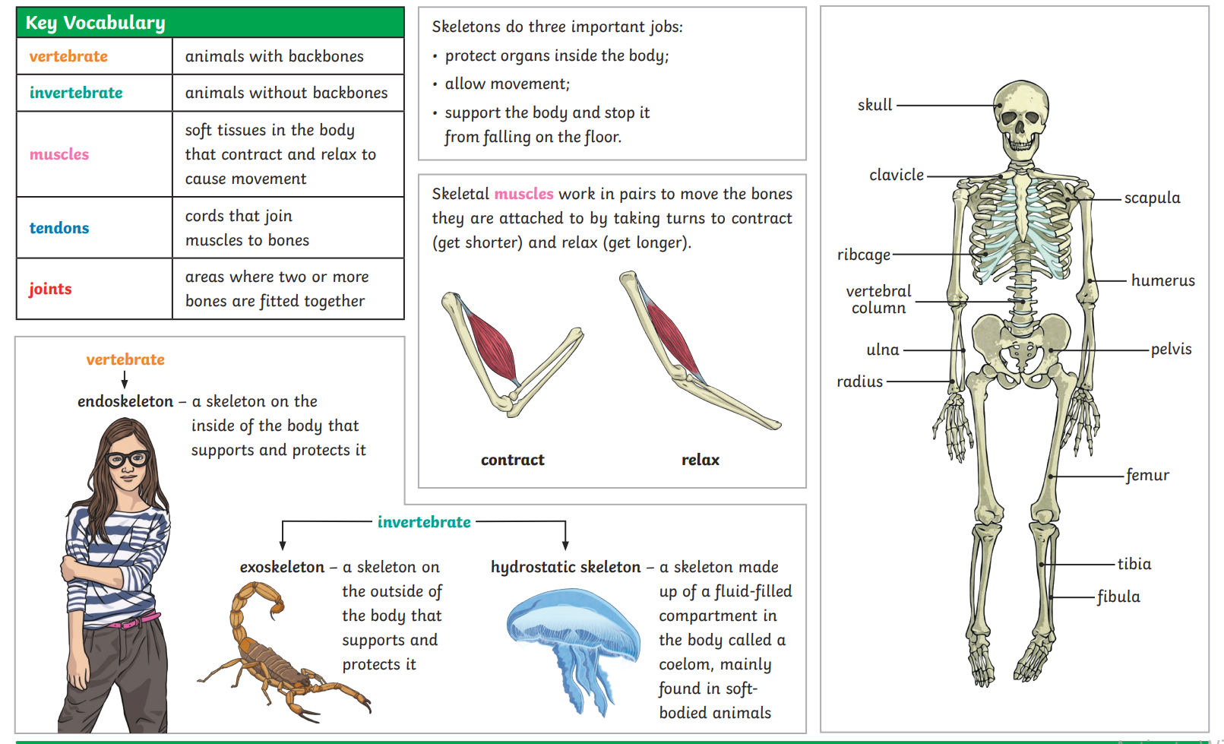 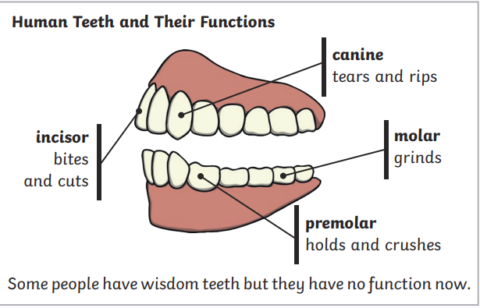

Find out more about skeletons here:

<https://kids.kiddle.co/Skeleton>

<https://www.bbc.co.uk/bitesize/topics/zv9qhyc/articles/zr942sg>

<https://www.bbc.co.uk/bitesize/topics/z7x78xs/articles/zqfdpbk>

Knowledge Organiser

Rubies Class

Autumn 1 Animals Skeletons and Teeth

Find out more about teeth: <https://www.bbc.co.uk/bitesize/topics/z7x78xs/articles/zsp76yc>

<https://www.youtube.com/watch?v=vcNAhUqH9U0&ab_channel=SmileandLearn-English>

You can limit tooth decay by:

* Limiting sugary food and drink
* Brushing your teeth twice a day with a fluoride toothpaste
* Visiting your dentist regularly