DT - Seasonal Food Rubies Class Autumn 1 2022

* Food is produced all around the world.
* Different food is grown, reared and caught. Some of this is seasonal.

**Some of the food we eat is seasonal in the UK. This means it only grows at certain times of the year.**

**All the food we eat has to be grown, reared or caught.**

**Fish and shellfish are caught.**

**Animals are reared.**

**Plants are grown.**

**Winter**

(December, January, February)

**Spring**

(March, April, May)

**Autumn**

(September, October, November)

**Summer**

(June, July, August)

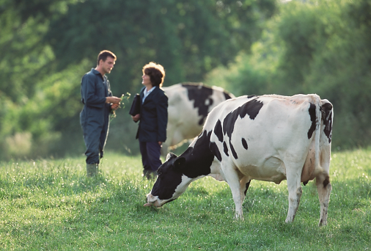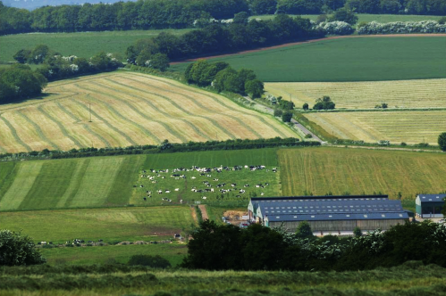

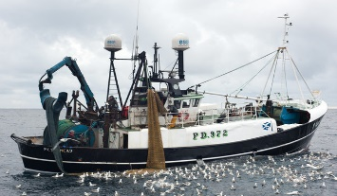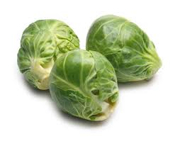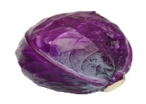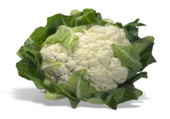

In the UK, some food is also grown in glasshouses. This means that the food is available at different times to that grown outside.

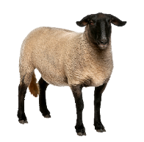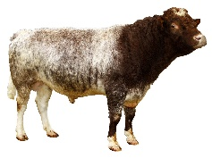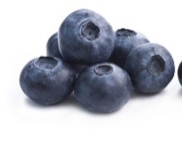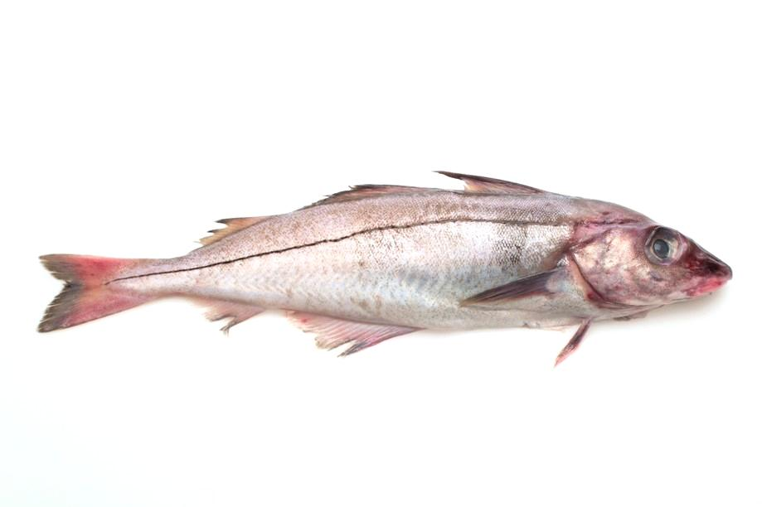

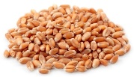

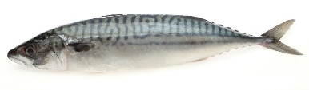

**Where is my food from?**Once grown, reared or caught, food is processed to make it edible and safe. For example:

* milk is from a dairy cow;
* apple juice is from apples which grow on trees;
* a tomato is a fruit which grows on a plant;
* mashed potato is made from potatoes (a plant) which grows under the ground;
* ham and bacon are made from pork which is the meat from a pig;
* toast is made from bread, bread is made from flour, flour is made from the plant called wheat (it is milled).

Some food has labels that tell us more about the animals’

welfare or how the food was grown.

The Red Tractor

Logo shows that

farmers look after

their animals and

produce food

safely.

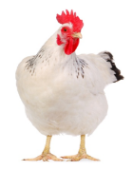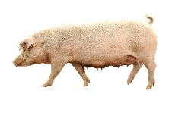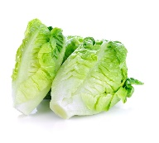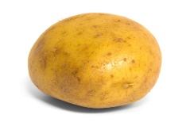

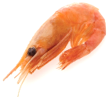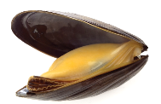

**Food is produced all around the world.**A lot of the food we eat is grown in the UK, but some food comes from other countries where the weather or seasons are different to ours.

**UK food World food**

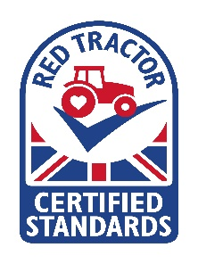

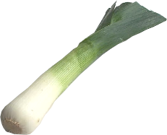

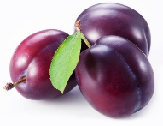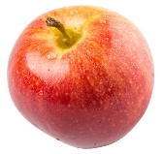

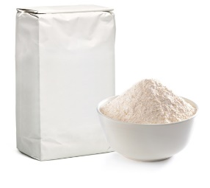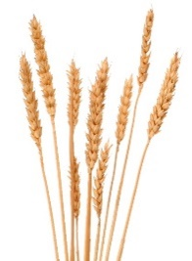

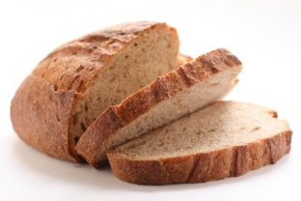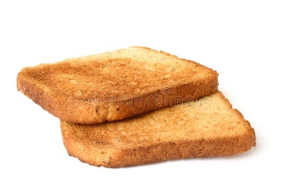

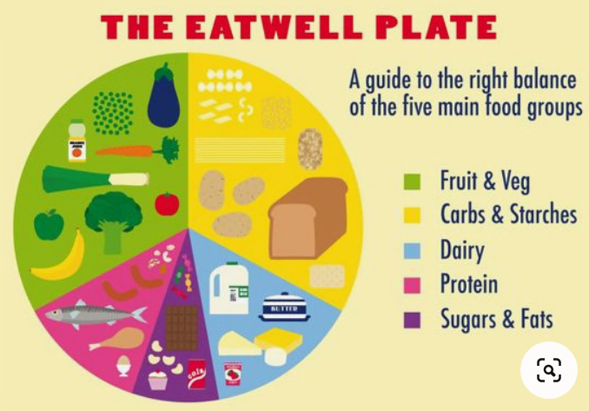

To find out more, go to: <https://bit.ly/3lm4uj3>

**Final Task**

Can you create a menu using only seasonal food? Don’t forget to use the seasonal food sheets provided. Is your meal a balanced one?