All Saints School Association
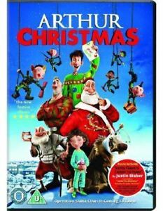
CHRISTMAS FILM NIGHT EVENT
Friday 6th December 2019
How can Santa deliver billions of presents to the whole world in just one night? With an army of one million combat-style Field Elves and a vast, state-of-the-art control centre under the ice of the North Pole! So how could this incredible operation have missed one child? To Santa’s young son, Arthur, it threatens to end the magic of Christmas. With retired Grandsanta, a rebellious young elf, an old sleigh and some untrained reindeer, Arthur sets out on a crazy mission to deliver the last present! Deck the halls with excitement, fun and wonder in this new Christmas classic!
UNIVERSAL RATED
Suitable for all Contains very mild language and mild comic threat
Tickets are £3 each which includes hot chocolate and cookies for your child to enjoy whilst watching the film.
Viewing of the film starts at 5.30pm and collection time at 7pm The children may come back in their pyjamas and bring their favourite snuggly friend and a comfy pillow for the evening
Please return the booking slip to the school office no later than Wednesday 4th December 2019 We can then ensure we have enough refreshments ready for the film night event
……………………………………………………………………………………
I would like my child to attend and I give consent for my child to watch the Arthur Christmas film on Friday 6th December 2019 and will collect my child at 7pm.
Childs full name…………………………………………………………………
Class……………………………………………………………………………...
Parent/Carer Signature………………………………………………………...
I enclose £……

