**DT - Food hygiene, safety and cooking Rubies Class Autumn 1 2022**

* Buying, storing, preparing and cooking food safely and hygienically are vital for health.
* There is a range of additional food skills and cooking techniques, which enable a wide range of dishes to be made.

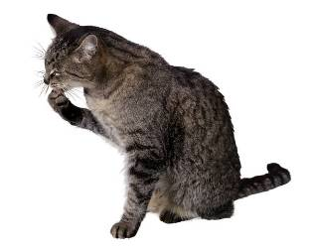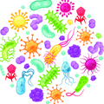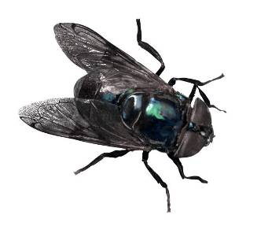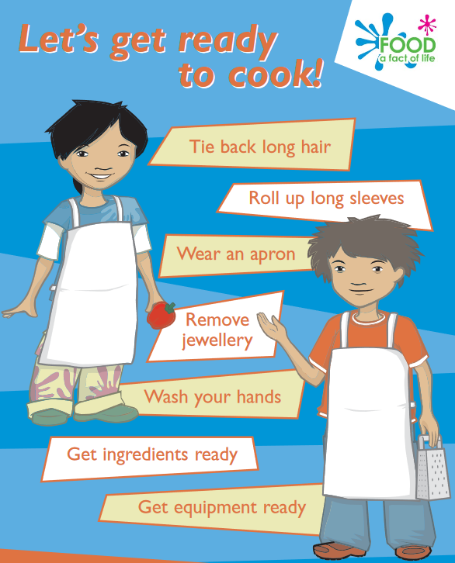

**Task:** Make a list of the steps you would take before, during and after cooking to make sure you follow good food hygiene and safety practices.

**It is important to take care when using sharp and/or hot equipment so that you don’t hurt yourself or someone else.**

**Food needs to be stored properly and within its date mark.**

**There are lots of food skills which enable you to extend the range of dishes you can already cook.**

**Baby leaf salad**

Keep refrigerated.

Once opened consume within 24 hours and by the ‘use-by’ date shown.

**Food labels provide useful information to the consumer.**

**Food can be purchased from a variety of sources.**



**Food spoilage**

When food spoils, the following may change:

* appearance;
* taste;
* texture;
* smell.

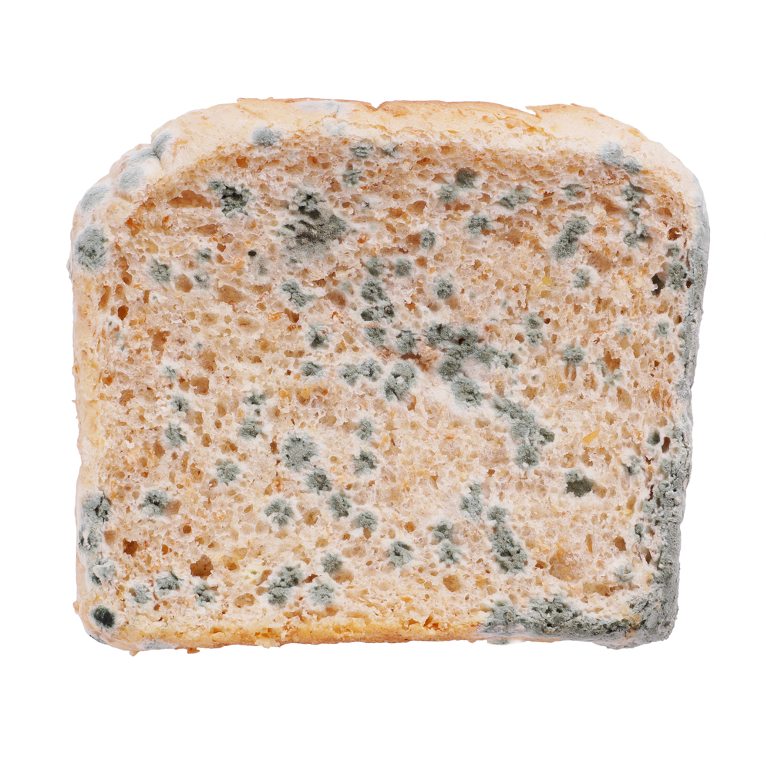 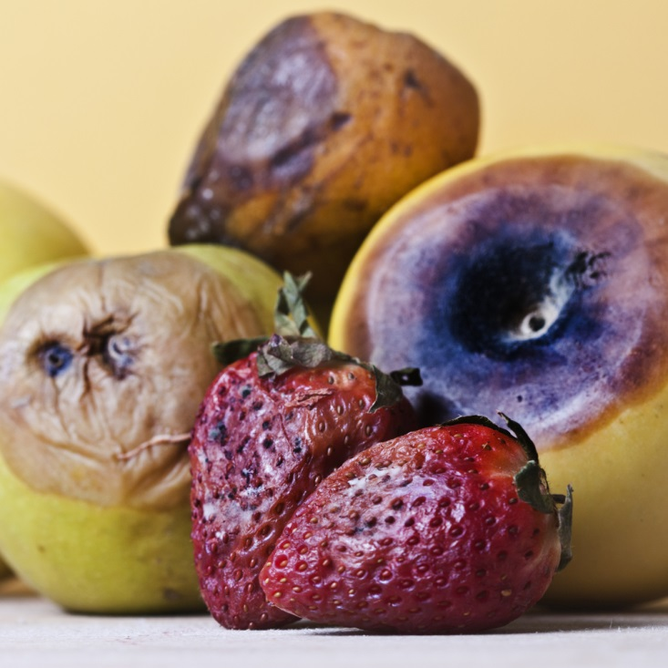

**Good personal hygiene is vital when cooking to avoid the risk of food poisoning.**

**Microorganisms**

Microorganisms are everywhere. They can be carried by food, people, dirty equipment, animals and pests. Most are harmless.

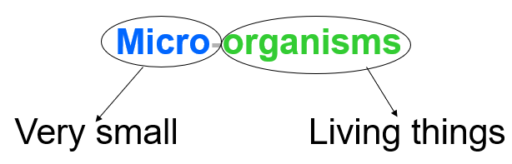

**Food can spoil and decay due to the action of microbes, insects and other pests/pets.**

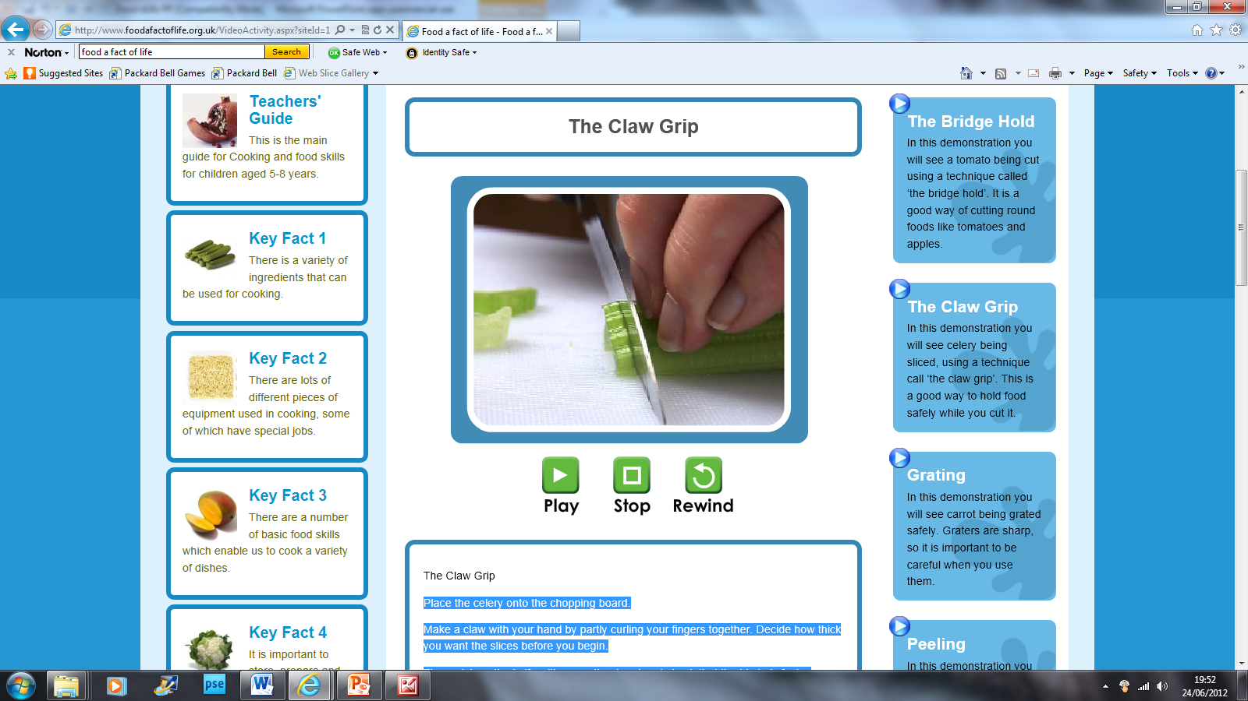

**The bridge hold and claw grip should be used when cutting food to avoid harm.**

**Bridge hold Claw grip**

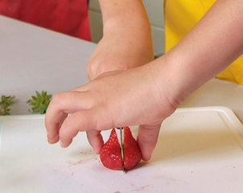

**Basic cooking skills are required to make a dish.**

**Grate Knead**

**Measure/weigh Peel**

**Roll-out Rub-in**

**BEST BEFORE:**

**25/08/21**

**STORE IN A COOL DRY PLACE**

**USE BY:**

**25/08/20**

**KEEP REFRIGERATED**

**There are a number of basic food skills which enable you to prepare a variety of simple dishes.**

**These can include:**

* cutting (with a knife);
* grating.
* juicing;
* kneading;
* measuring;
* peeling;
* rolling-out;
* rubbing-in;
* stirring;
* washing;
* weighing.