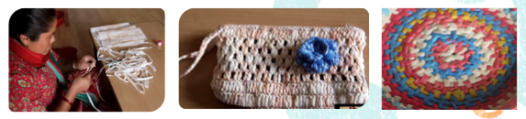

**Home Learning Project Spring term 2018**

This term’s home learning project is linked to our Science learning on properties of materials. You will need to investigate properties of plastics and the impact plastics can have on the environment. You will go on to design a product made from used plastics like some women in Nepal have been doing in order to sell and make some money. There are several tasks you will need to complete that are described below. Each one is numbered according to the week it should be completed by. There’s no need to wait though; feel free to work ahead of my schedule! If you need to borrow any school equipment, let me know and I can organise it for you.

Mrs Beecham

Plastics Challenge

1. Identifying plastics sheet. Collect a range of plastics from home and test. Record your findings on the sheet.
2. How long does it take for different items to decompose? Research the decomposition times for the items on the sheet then label and order them.
3. Recycling plastics – what recycling facilities are available from your home or local area? Which items do people in your home recycle? What fraction of plastics that you use can you recycle in a week? Write a report on plastic recycling in your home.

This week, it would be a good idea to collect a range of plastics for your design task which starts next week.

1. Now it’s time to test out some techniques and research some ideas for your own product made from used plastics. You need to have produced a final design idea by the end of this week.
2. and 6. Produce your final product. Get making your high quality product! It would be helpful to photograph the making process so that you have the images to use for your next task.

**Project progress check Monday 19th Feb. I will come into school on this day to mark and collect projects. Make sure yours is there in time for me to see.**

1. Produce instructions for Nepalese women to make your product. These can be written by hand, typed or you may wish to produce a PowerPoint presentation or video. Make sure that you think carefully about giving detailed and interesting instructions.
2. Now it’s time to think about money. How much could you sell your product for? Ask people what they would pay. What were the costs? How long does it take to make each one? What could the potential profit for one day’s work be? Produce a short report on all the prices and costs for your product.

Final project deadline: 15th March