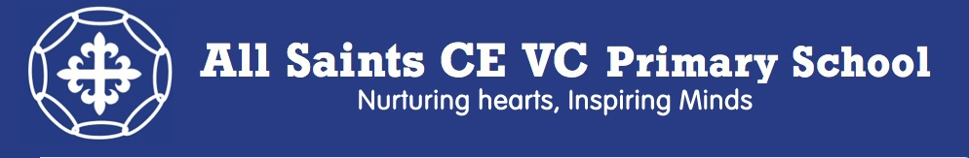
Active Lifestyle Newsletter
Edition 1 – Autumn Term 2018

Dear families,
Our children are so important to all of us that this year I am going to write three special newsletters to you, all about ‘active lifestyles’. I hope these newsletters will not only keep you up to date with what we are doing in school to help your child’s physical and mental health but also help you with some top tips on how to further support your child at home.
With thanks
Mrs Lisa Regan
Sport Leader and Deputy Head Teacher

So why is an active lifestyle important?
Did you know 4/5 children are not active enough to maintain good health in Dorset?
Did you know 25% of 11 year olds reported that they feel they do not get enough sleep in England?
Did you know 10% of 11-16 year olds have a mental health disorder in England?
Did you know 48% of 11 year olds are not eating at least 5 portions of fruit/vegetables a day in England?
Did you know 33% of year 6 children are overweight or obese in England?
Did you know there are 29,000 under the age of 14 who now have diabetes in England?

What does ‘being active’ offer to children?
Being ‘active’ provides a range of psychological (mental), social and physical benefits, for example:
- Reduced body fat
- Reduced high blood pressure
- Improved skeletal health
- Reduced likelihood of risk factors for chronic conditions such as diabetes
- Increased self-confidence and self-worth
- Reduced symptoms of depression and anxiety
- Improved social skills, including a sense of ‘fair play’ and justice

Our ‘Active Lifestyle’ Twilight evening:
On Tuesday 9th September 2018 we had a fabulous evening that was ‘active jam packed’ from ‘baby shark’ to a competitive fruit art attack! It was lovely to have Governors, Staff, Children and Families all attending. Thank you to our 9/95 families who supported us in our school development evening this year – your input really does have an amazing impact on what we do here at All Saints.
Well done to those people who made a pledge on the night for what they will achieve to live a more active lifestyle. Don’t worry if you weren’t able to make the twilight - why not make your pledge now ... before your New Year’s resolution! Here are our pledges from twilight:
- Walk 3 miles a day
- Do yoga every morning
- Go for walks in the countryside and be an active outdoor learner!
- Try my hardest when doing any sport activities and do star jumps everyday
- Complete a mile at the weekends
- Stop drinking as many fizzy drinks
- Change my lifestyle - I don’t need to have a plan to exercise. I can exercise anytime... when cooking, watching TV, gardening etc
- Endeavour to put active learning into interventions to make children feel their learning is fun, enjoyable as well as improve their overall health
- Look at labels on foods and drinks more closely
- Do something active every morning
- Make my children’s home learning more fun and active
- Taking regular breaks at work to walk away from my computer screen
- Removing chairs more often from the classroom
- Extend early years fitness
- Include some active learning in interventions like hopping and skipping when repeating sentences, using the hall when identifying and saying sounds and walking when talking!
- Run an after school tennis and cricket club
- Park away from the school and walk rather than parking in the car park
- Take more active breaks
- Make learning active when possible
- Encouraging the link between physical, mental health and well being
- Make lessons active and fun
- Stop having sugar in my tea and coffee
- Walk and bike ride more
- Walk the dog a bit further each day
- Challenge myself to be more active and move more during my learning
- Run a club for parents to become more active
- Plan more active lessons throughout the day
- Go on more adventures
- Plan an active learning element into each lesson/objective
- Start swimming again
Healthy Lifestyle Achievement Post Box!
If you have achieved your pledge or do something great to develop your active lifestyle, whether cooking a healthy meal, drinking a low sugar drink or moving more, take a photo and pop your name on the back and a brief description about what you did and how you benefited from it and pop it in our healthy lifestyle achievement post box in the entrance to our school. Each term Mrs Regan will pick out a winner who will win a prize! You can post more than once ... remember you’ve got to be in it to win it!!! Don’t forget children and/or adults can post an achievement and your achievements may be shared on our school newsletters, displays or website.

Funding:
This year we have been lucky to receive some further funding to develop active learners within our school. The focus of these funds is to support the Government vision:
‘All pupils leaving primary school physically literate and with the knowledge, skills and motivation necessaryto equip them for a healthy lifestyle and lifelong participation in physical activity and sport.’
The key objective of the funding is to:
‘Achieve self-sustaining improvement in the quality of PE and sport in primary schools.’
Most importantly we must demonstrate the impact of our spending, which should provide support for:
- Engaging pupils in regular physical activity
- Raising the profile of PE
- Increasing the confidence, knowledge and skills of all staff in teaching PE and sport
- Providing a broader range of sports and activities offered to all pupils
- Increasing the participation of children in competitive sports.
Thank you to those families, governors, children and staff who proposed ways of which we could use this funding at our twilight evening. Our leadership team will be working together to look at finances and possibilities and our final proposal and report will be published on our website by April 2019.

Who is Who?!
Lisa Regan | PE Leader
Bethany Scott | Intra School Games Organiser
Kevin Noyce | Inter School Games Organiser and Sports Coach
Rachel Amor | Sports Ambassador Leader and Change4Life Leader
Wendy Taylor | School Development Group Chair (Governor)
Paul Tomlin | Sports Premium Governor and Finance Governor
Leanne and Jazmyn | Sports Ambassador Leaders (Children)
Samyra, Alix, Henry and Sapphire | Sports Ambassadors (Children)

Barriers to Active Lifestyles – can we help you STAMP on those barriers and get more active?
We appreciate that an active lifestyle is difficult to accomplish when there are so many barriers. At our twilight, we looked at some ways we could break through these barriers and become more active:
Barriers – what stops us being active? | Resolutions – possible ways to overcome those barriers!
‘I don’t have enough time in the day’ | Make time! No T.V. or less T.V. Be more time efficient and dedicate a time when ‘being active’ is achieved.
‘I can’t be active when the weather is bad’ | Buy an umbrella or good waterproofs! And don’t forget reflective clothing and a torch. Remember that there are lots of ways of being active indoors too.
‘I always have to drive to work/school as I live too far away’ | Park away from the school and walk the rest of the way.  Cycle to school.  Leave earlier and park nearby.  Get a trolley to carry all your things in! Or take less home!
‘I haven’t been active in years’ | Start slowly! Little and often is key. Every little bit helps.
‘I can’t afford it’ | Look for deals or special offers.  Do activities that are free like running round the park.
‘I have no childcare’ | Do something with your child! Like swimming or walking through the woods.

Contact details for clubs and ‘active’ events or places near you!
Gryphon School Sports Centre - http://www.gryphonsportscentre.org.uk/ or phone 01935 814011.

Sherborne Rugby Club - Phone +44 7808 096810 or email: contact@sherbornerugby.co.uk

North Dorset Netball Club – http://www.northdorsetnetballclub.co.uk/ email: NDNC@hotmail.co.uk

Sherborne Tennis Club - https://www.sherbornetennis.com/

Oxley Swimming Pool - https://www.oxleysc.com/swimming-pool or ring 01935 818 270
Orchard Gymnastics Club - 01935 425682 or email: rolling@orchardgymnastics.co.uk ​​​​
If your child goes to a club outside school, please let us know any details that we could post here next time so that others can join too!
‘Active’ clubs at All Saints:
It is so important that children get the opportunity to take part in clubs. It helps them build their social skills, learn a love for a different type of activity, develop an appreciation for a healthy lifestyle, learn how the body works, improve their skill and motor development, reduces stress, improves physical fitness and being active improves academic performance.
Did you know, that this half term, in our Key Stage 2 classes, 19/49 children are not taking part in ANY ‘active’ clubs at All Saints. That’s 39%! If you are not sure whether your child is opting out on being active, please ask your child’s class teacher at our parent consultations and work together to get your child more active.
This half term, children have been able to access the following sporting clubs:
- Basketball
- Fitness
- Football
- Dance
- Archery
- Netball
Please contact our school office if you would like your child to attend any of the above clubs. Our clubs change every half term so please keep an eye out for our ‘what’s on this week’ and additional notes home that keep you informed! We are excited that next half term gymnastics and dodgeball are being introduced… will your child attend?

Inter-School Competitions:
It is no surprise that the Government are keen for an increase in children taking part in competitive sports. It helps children to stay active and healthy but also enables children to learn important life lessons about teamwork and fair play. Participating in sports teaches children how to compete in the real world. As they grow older, they'll face competition in school, in the workplace and other areas of life. But these competitions don't have to be negative or unhealthy. Playing sports can help children understand how competition works in a friendly environment, and that if you try your hardest, you have a better chance to succeed.
Your child has now been placed into a coloured group for this year. The four colours are red, blue, yellow and green and link to the Olympic colours. This helps when teaching the children about the sporting values:
Olympic values – Friendship, Respect and Excellence
Paralympic values – Determination, Inspiration, Courage and Equality.
They will take part in competitions within school every 5 weeks, at the end of their PE learning of a particular sport. Results will be displayed in our school sports hall and on our termly newsletter. If your child is unable to tell you which colour team they are in, please do not hesitate to contact their school teacher who will be able to tell you! Our sporting year will end with our incredible sports day, where children will compete in their coloured groups… who will hold the cup up high and be victorious this year?!
Tag Rugby Results:
Coloured Group | Total Points so far
Red | 14
Blue | 16
Yellow | 24
Green | 18

Intra—School Competitions:
These are games that take part against other schools. They can be in the form of a ‘friendly’ game, sporting festival, tournament or competition. So far we have completed:
Date: | Event: | Comments:
26th September 2018 | Football Game – Home vs Buckland Newton (Years 4,5,6)’ | Sports fixtures began this week with a friendly football match against Buckland Newton. Our newly assembled team played really well and were just pipped at the post by 1 goal’
2nd October 2018 | Netball Game – Away vs Thornford (Years 5+6) | ‘On Tuesday the Netball team played their first match of the season against Thornford School. The teams were evenly matched and All Saints played well exhibiting great sporting behaviour but narrowly missed a win.’
11th October 2018 | Year 6 Tag Rugby Tournament (Sherborne Schools) | ‘’On Thursday our children took part in the Sherborne Area Tag Rugby Tournament at Sherborne Primary School. They played really well and made Miss Scott extremely proud.’
16th October 2018 | Years 1 and 2 Football Festival | ‘On Tuesday, some children in Yrs1 &2 took part in a Sherborne Area friendly football tournament. There was much excitement and everyone enjoyed the event. Miss Scott was very proud and said “What a great team they will make when they are older!”
17th October 2018 | Football Game – Home Vs Bradford Abbas | ‘On Wednesday our older footballers played a match against St Mary’s School, Bradford Abbas. Although they did not secure a win on this occasion, the play was excellent – particularly in the second half after the half time team talk from Miss Scott! Well done to all.’

What have we achieved so far this academic year?
- PE leaders, Lisa Regan and Wendy Taylor attended training titled ‘Active Learning’. Notes from this training and an action plan was shared with all staff at All Saints
- PE lead, Lisa Regan led a twilight for parents, carers, children, Governors and staff on ‘Active Learning’
- Miss Scott attended a meeting with other Sherborne Schools to agree the fixture timetable for this year
- Attended a sporting festival for Year 2!
- Played ‘friendly’ matches
- Played in a Tag rugby competition
- Created a new healthy lifestyle achievement box
- Written our first Active Lifestyle newsletter
- Created two ‘active lifestyle’ displays within school
- Completed an inter school competition in tag-rugby
- Mrs Regan and Mr Noyce created a new assessment document for PE
- Adapted how we deliver active learning breaks at All Saints, including stopping Wake and Shake and introducing a 15 minute a day active challenge

The year ahead:
- Governor of the month visit to monitor active learning and measure impact (November 2018)
- Staff Meeting – Improving active learning at All Saints (Spring 2019)
- Leadership Meeting – PE premium funding and spending (Spring 2019)
- More fixtures, tournaments and festivals (termly)
- More clubs!
- Swimming every day (2nd Summer half term)
- Sports day (summer term)
- Fundraiser – promoting being active
- Change4Life club (Summer 2019)
We can’t wait to share these with you and the impact they have had in our next newsletter!

Physical fitness is not only one of the most important keys to a healthy body; it is the basis of dynamic and creative intellectual activity.
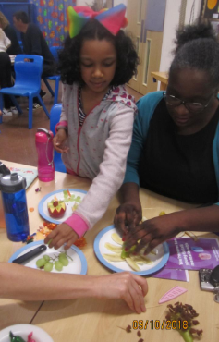
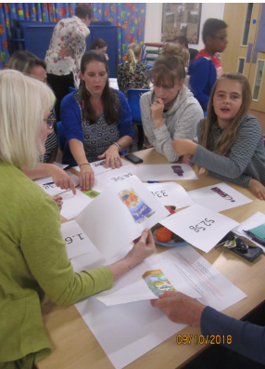
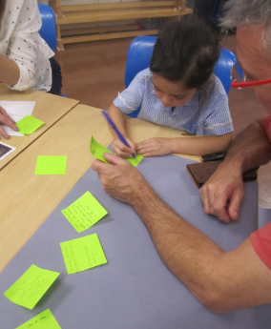
John F. Kennedy
